**Assignment #2**

**Introduction to Linux**

**Ammad Ali**

Problem Statement:

Tom Cruise has implemented his own flavor of customized Ubuntu version but he wants to make sure if it has the ability to kill the programs according to the user will. He has a script running on the system named “Ghost_Protocol.py”. He has asked you to kill that script through the terminal.

Solution:

Step 1:

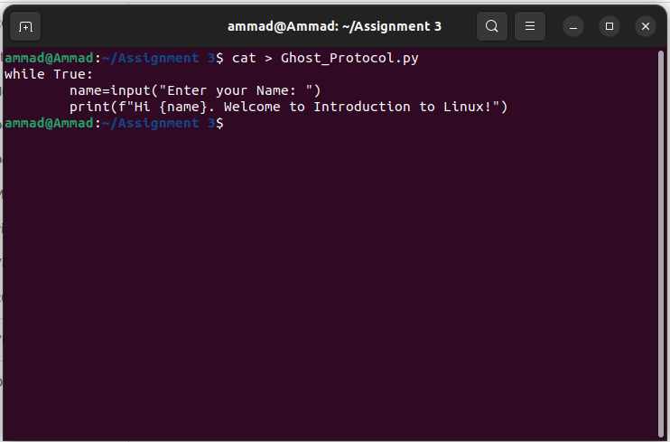

I first opened the “/home/Assignment 3” directory in the terminal. I then used the cat command to give the file a name and write down the python code in the file and saved it using CTRL+D. An infinite while loop was used in the code so the code continued to run in the background.

Step 2:

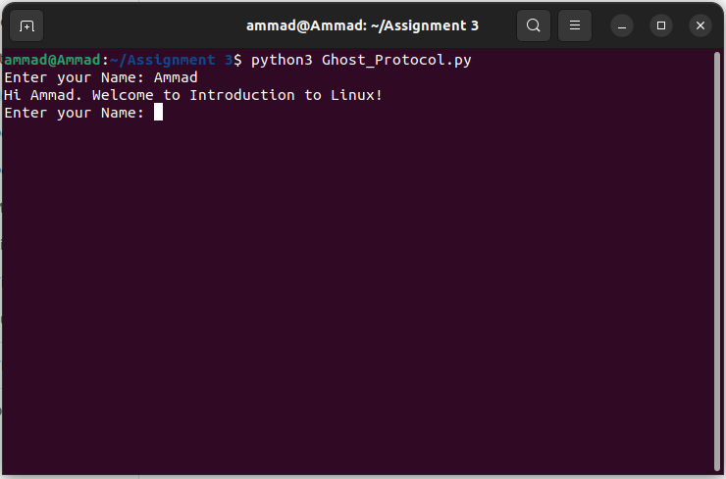

I then used the python3 command to run the Ghost_Protocol.py file that was saved in the directory. The python code was executed in the terminal.

Step 3:

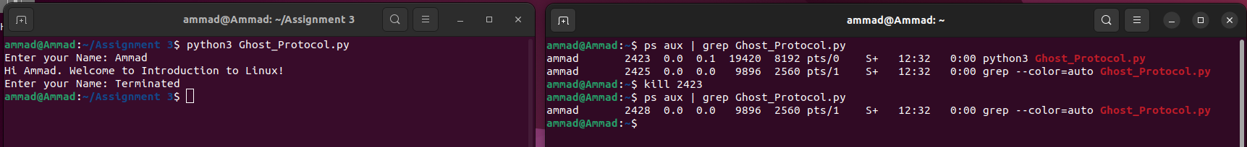

In the end, I opened another terminal and used ps aux | grep <name_of_file> command which returned all the Ghost_Protocol.py processes. As you can see, 2 processes were returned out of which the first one was the python3 script process (it was ran using the python3 command) as it is mentioned in the second last column of the details returned. The second column showed the PIDs of the process. I then used the kill <pid> command to kill the script. We can see in the first terminal that the script was terminated. Upon running the ps aux command again, we can see that the Ghost_Protocol.py process that was run by python3 command has been killed.